

Semester Two Examination, 2021
Question/Answer booklet

MATHEMATICS
APPLICATIONS
UNITS 3&4

SOLUTIONS
Section Two:
Calculator-assumed
WA student number: In figures

In words

Your name
Number of additional
answer booklets used
(if applicable):

Time allowed for this section
Reading time before commencing work: ten minutes
Working time: one hundred minutes

Materials required/recommended for this section
To be provided by the supervisor
This Question/Answer booklet
Formula sheet (retained from Section One)

To be provided by the candidate
Standard items: pens (blue/black preferred), pencils (including coloured), sharpener,
correction fluid/tape, eraser, ruler, highlighters

Special items: drawing instruments, templates, notes on two unfolded sheets of A4 paper, and up to three calculators, which can include scientific, graphic and Computer Algebra System (CAS) calculators, are permitted in this ATAR course examination

Important note to candidates
No other items may be taken into the examination room. It is your responsibility to ensure that you do not have any unauthorised material. If you have any unauthorised material with you, hand it to the supervisor before reading any further.

Structure of this paper

Section | Number of  questions  available | Number of  questions to  be answered | Working  time  (minutes) | Marks  available | Percentage  of  examination
Section One:  Calculator-free | 8 | 8 | 50 | 52 | 35
Section Two:  Calculator-assumed | 13 | 13 | 100 | 98 | 65
 |  |  |  | Total | 100

Instructions to candidates

1. The rules for the conduct of examinations are detailed in the school handbook. Sitting this examination implies that you agree to abide by these rules.

2. Write your answers in this Question/Answer booklet preferably using a blue/black pen.
Do not use erasable or gel pens.

3. You must be careful to confine your answers to the specific question asked and to follow any instructions that are specific to a particular question.

4. Show all your working clearly. Your working should be in sufficient detail to allow your answers to be checked readily and for marks to be awarded for reasoning. Incorrect answers given without supporting reasoning cannot be allocated any marks. For any question or part question worth more than two marks, valid working or justification is required to receive full marks. If you repeat any question, ensure that you cancel the answer you do not wish to have marked.

5. It is recommended that you do not use pencil, except in diagrams.

6. Supplementary pages for planning/continuing your answers to questions are provided at the end of this Question/Answer booklet. If you use these pages to continue an answer, indicate at the original answer where the answer is continued, i.e. give the page number.

7. The Formula sheet is not to be handed in with your Question/Answer booklet.
Section Two: Calculator-assumed 65% (98 Marks)
This section has thirteen questions. Answer all questions. Write your answers in the spaces provided.

Working time: 100 minutes.

Question 9 (5 marks)
The table below shows the duration and immediate predecessors for all the activities required to complete a project.

Activity | $$U$$ | $$V$$ | $$W$$ | $$X$$ | $$Y$$ | $$Z$$
Duration (minutes) | $$17$$ | $$45$$ | $$21$$ | $$11$$ | $$13$$ | $$32$$
Immediate predecessors | $$-$$ | $$-$$ | $$U$$ | $$V$$ | $$V, W$$ | $$X, Y$$

(a) Construct a project network to show all the above information. (3 marks)
Solution
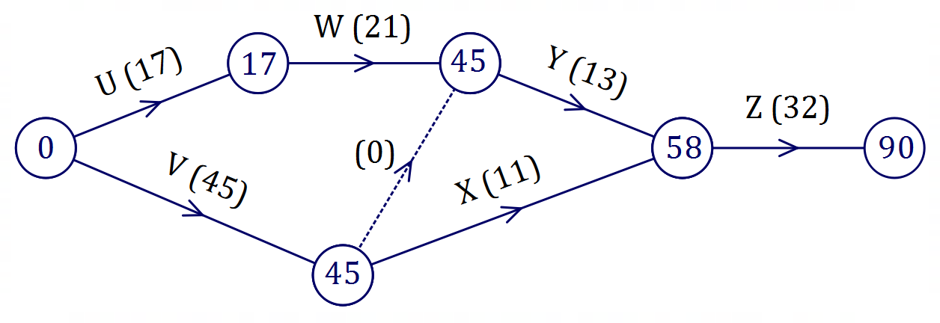

Specific behaviours
network with correct precedence relations
ü uses dummy edge correctly
ü adds direction and labels to edges

(b) Determine the minimum completion time for the project and list, in order, the activities that lie on the critical path. (2 marks)
Solution
Minimum completion time is $90$ minutes.

Activities on critical path: $V, Y, Z$.

Specific behaviours
minimum completion time
ü ordered list of activities on critical path

Question 10 (9 marks)
The body length and eye diameter of eight tropical fish of the same species are shown in the table below.

Body length, $L$ cm | $$6.3$$ | $$11.9$$ | $$3.8$$ | $$8.2$$ | $$9.1$$ | $$10.5$$ | $$5.2$$ | $$7.5$$
Eye diameter, $D$ mm | $$9.3$$ | $$8.6$$ | $$9.9$$ | $$9.1$$ | $$9.0$$ | $$8.7$$ | $$9.8$$ | $$9.4$$

(a) Use your calculator to graph the above data and hence describe the direction and strength of the linear association between the variables. (1 mark)
Solution
The association is strong and negative.

Specific behaviours
states strong and negative

(b) Determine the coefficient of determination for the linear association and interpret its value in context. (2 marks)
Solution
$$r^{2}=0.950$$
$95\%$ of variation in the eye diameter can be explained by the variation in body length.

Specific behaviours
$r^{2}$, to at least $2$ decimal places
ü correct interpretation of coefficient

(c) Determine the equation of the least-squares line to predict $D$ from $L$ and interpret the slope of the line in context. (3 marks)
Solution
$$D=-0.17L+10.55$$

The slope means that for every $1$ cm increase in length of a fish, the eye diameter is expected to decrease by $0.17$ mm.

Specific behaviours
equation, using given variables
ü indicates as one variable increases, the other decreases
ü quantifies relationship, using units

(d) Predict the eye diameter of another tropical fish of the same species that has a body length of $5.6$ cm and give two reasons that support the validity of this prediction. (3 marks)
Solution
$$D\left(5.6\right)=9.6 \text{mm}$$

Prediction is valid because correlation is strong, and it does not involve extrapolation.

Specific behaviours
calculates diameter
ü states strong correlation
ü states interpolation or no extrapolation

Question 11 (7 marks)
A builder bought a scissor lift for $\$38 000$ and for accounting purposes will depreciate its value by $15\%$ annually.

(a) Show that the value of the lift after one year will be $\$32 300$. (1 mark)
Solution
$$\$38 000×0.85=\$32 300$$

Specific behaviours
clearly shows any correct method

(b) Write a recursive rule to calculate the value of the lift, $T_{n}$ in dollars, after $n$ years.
(2 marks)
Solution
$$T_{n+1}=0.85×T_{n}, T_{0}=38 000$$

Specific behaviours
recursive part
ü initial term using $T_{0}$

(c) Calculate the value of the lift after $4$ years. (1 mark)
Solution
$$T_{4}=\$19 836.24$$

Specific behaviours
correct value (or rounded to nearest $)

(d) Deduce the $n^{th}$ term rule for the value of the lift after $n$ years. (1 mark)
Solution
$$T_{n}=38 000{\left(0.85\right)}^{n}$$

Specific behaviours
correct rule

(e) Determine the least number of years that must pass for the lift to depreciate by more than $80\%$ of its original value. (2 marks)
Solution
$20\%$ of value will remain, so value will be $\$7600$.
$$T_{9}=8801, T_{10}=7481.$$

Least number of years is $10$.

Specific behaviours
indicates required value
ü correct number of years

Question 12 (7 marks)
A reducing balance loan is defined by the recurrence relation $T_{n+1}=a×T_{n}-b, T_{1}=c$, where $Tn$ is the balance of the loan in dollars at the start of month $n$. The relation was used to create the following spreadsheet.

Month  $$n$$ | Balance of loan at start of month $n$ | Monthly interest | Monthly repayment | Loan balance carried forward
$$1$$ | $$16 500.00$$ | $$140.25$$ | $$425.00$$ | $$16 215.25$$
$$2$$ | $$16 215.25$$ | $$137.83$$ | $$425.00$$ | $$15 928.08$$
$$3$$ | $$15 928.08$$ | $$135.39$$ | $$425.00$$ | $$X$$
$$4$$ |  | $$Y$$ |  | $$Z$$

(a) Determine the annual percentage interest rate that applies to the loan. (2 marks)
Solution
$$140.25÷16500=0.0085$$

$$0.0085×12×100=10.2\% \text{pa}$$

Specific behaviours
calculates monthly rate
ü correct annual rate as percentage

(b) State the value of each of the constants $a, b$ and $c$ in the recurrence relation. (2 marks)
Solution
$$a=1.0085$$

$$b=425, c=16 500$$

Specific behaviours
value of $a$
ü value of $b$ and value of $c$

(c) Determine the value of $X$, the value of $Y$ and the value of $Z$ shown in the spreadsheet.
(3 marks)
Solution
$$X=15928.08+135.39-425.00=\$15 638.47$$

$$Y=15 638.47×0.0085=\$132.93$$

$$Z=15 638.47+132.93-425.00=\$15 346.40$$

Specific behaviours
value of $X$
value of $Y$
value of $Z$

Question 13 (8 marks)
A researcher observed a large number of cats, noting for each one its gender and the paw that it used to react to a stimulus placed in front of it. The numbers in each category are shown in the table below.
Cats | Left-pawed | Right-pawed
Male | $$27$$ | $$31$$
Female | $$28$$ | $$55$$

The researcher is interested in whether there is an association between the variables.

(a) Name one of the variables in the study and classify it as numerical or categorical.
(2 marks)
Solution
Name: Gender or Paw.
Classifies as Categorical.
Specific behaviours
names one variable
ü classifies variable

(b) Determine the percentage of left-pawed cats that were female. (2 marks)
Solution
$$\frac{28}{27+28}=\frac{28}{55}=50.9\%$$

Specific behaviours
indicates correct total for category
ü correct percentage (whole number ok)

(c) Use the above data to complete the following table so that it shows column percentages rounded to the nearest whole number. (2 marks)
Solution
See table
Specific behaviours
ü both columns add to 100
correct table

Cats (%) | Left-pawed | Right-pawed
Male | $$49$$ | $$36$$
Female | $$51$$ | $$64$$

(d) Explain whether the percentaged table suggests the presence of an association between the variables. (2 marks)
Solution
An association is evident between the variables as the pairs of percentages in each row (i.e., for each gender) are quite different.

Specific behaviours
states association
ü explanation using different percentages

Question 14 (9 marks)
The table below shows the number of new clients attracted by a business during the first three weeks of an advertising campaign, together with some derived values to assist in the analysis of the time series data.

Week | Day $(n)$ |  | New Clients | Weekly mean | Percentage of weekly mean
$$1$$ | Mon | $$1$$ | $$35$$ | $$40.6$$ | $$A$$
 | Tue | $$2$$ | $$40$$ |  | $$98.5$$
 | Wed | $$3$$ | $$44$$ |  | $$108.4$$
 | Thu | $$4$$ | $$43$$ |  | $$105.9$$
 | Fri | $$5$$ | $$41$$ |  | $$101.0$$
$$2$$ | Mon | $$6$$ | $$42$$ | $$B$$ | $$89.7$$
 | Tue | $$7$$ | $$44$$ |  | $$94.0$$
 | Wed | $$8$$ | $$52$$ |  | $$111.1$$
 | Thu | $$9$$ | $$49$$ |  | $$104.7$$
 | Fri | $$10$$ | $$47$$ |  | $$100.4$$
$$3$$ | Mon | $$11$$ | $$49$$ | $$55.2$$ | $$88.8$$
 | Tue | $$12$$ | $$55$$ |  | $$99.6$$
 | Wed | $$13$$ | $$59$$ |  | $$106.9$$
 | Thu | $$14$$ | $$56$$ |  | $$101.4$$
 | Fri | $$15$$ | $$C$$ |  | $$103.3$$

(a) Calculate the value of $A$, the value of $B$ and the value of $C$ in the table. (3 marks)
Solution
$$A=35÷40.6=86.2\% \\ B= \left(42+44+52+49+47\right)÷5=46.8 \\ C=55.2×103.3\%=57$$

Specific behaviours
value of $A$
value of $B$
value of $C$

(b) Determine the seasonal index for Thursdays. (2 marks)
Solution
$$I_{THU}=\left(105.9+104.7+101.4\right)÷3 \\ =312÷3 \\ =104\%$$

Specific behaviours
uses correct indices
ü calculates index as percent or decimal

(c) The least-squares line to predict the deseasonalised number of new clients $c$ from the day is $c=1.31n+37.1$. Stating any assumptions made, determine the best estimate for the number of new clients expected on Wednesday of Week 4. (4 marks)
Solution
Wednesday of Week $4$ is day $18$.

$$c=1.31\left(18\right)+37.1 \\ =60.68$$

$$I_{WEDS}=\left(108.4+111.1+106.9\right)÷3 \\ =326.4÷3 \\ =108.8\%$$

$$C=60.68×1.088 \\ =66.0$$

Expect $66$ new clients, assuming that the existing trend and seasonality continues into the future.

Specific behaviours
uses correct day to calculate deseasonalised number
ü calculates seasonal index for Wednesday
ü uses index to calculate whole number estimate
ü states assumption

Question 15 (8 marks)
Ten mains-powered smoke alarms must be installed in a building. The edge weights in the graph below represent the length of cable, in metres, required between adjacent alarms.

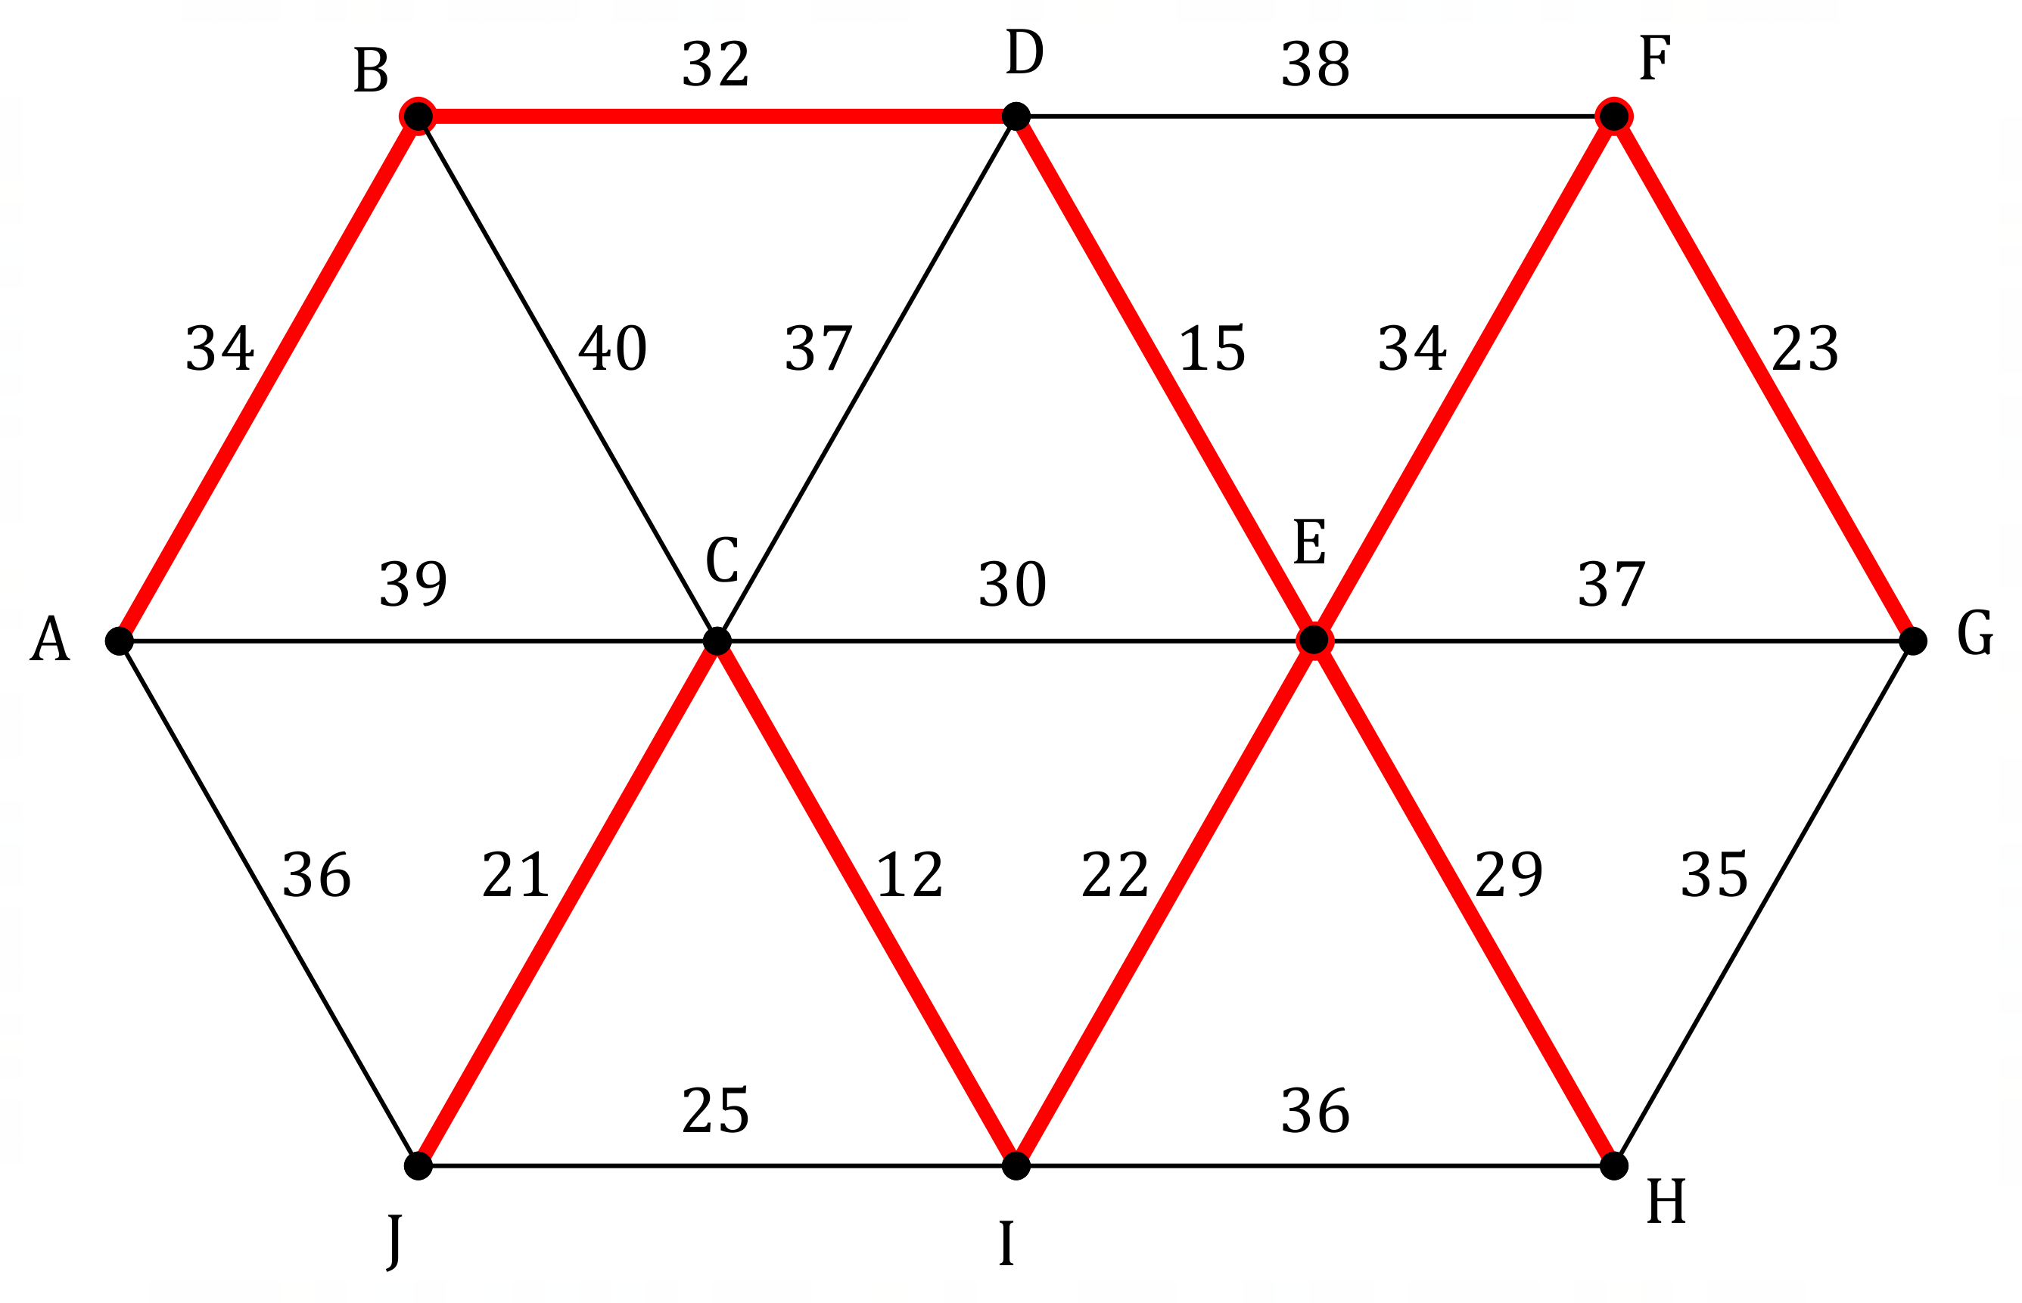

(a) Clearly identify the minimum spanning tree on the graph above. (3 marks)
Solution
See graph
Specific behaviours
any tree; ü any spanning tree; ü minimum spanning tree

(b) Determine the cost of installing the cabling between the alarms using the minimum spanning tree, given that each metre of cabling will cost $\$18.50$. (2 marks)
Solution
Sum of edges:
$$L=34+32+15+34+23+21+12+22+29=222 \text{m}$$
Total cost:
$$C=222×18.50=\$4107$$

Specific behaviours
sum of edges
ü calculates cost

(c) Explain how your answer to part (b) will change if smoke alarm $K$ is added to the system with cable lengths of $20, 21$ and $22$ metres to alarms $F, G$ and $H$ respectively. (A copy of the graph from the previous page is shown below if you wish to use it.) (3 marks)

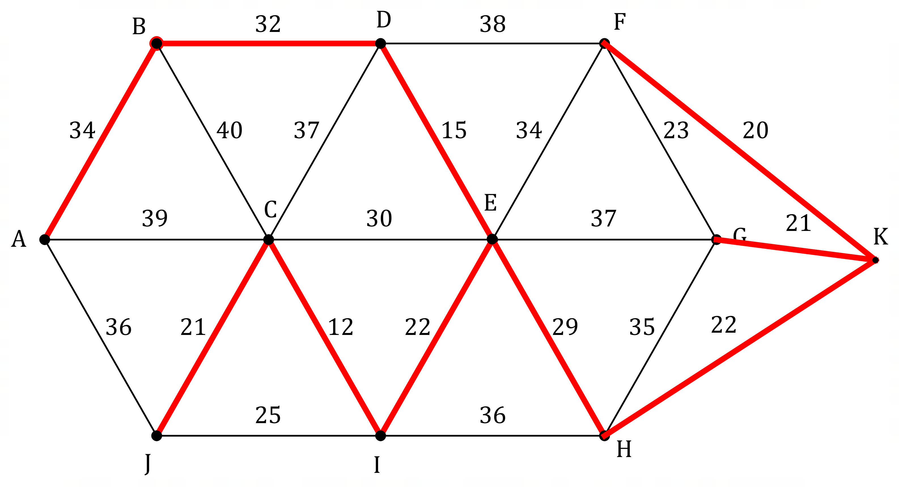
Solution
The minimum spanning tree changes so that edges $EF$ and $FG$ no longer used but edges $FK, GK$ and $HK$ are now included.

The edge sum increases by $6 \text{m}$ to $228 \text{m}$.

Total cost increases by $\$111$ to $\$4218$.

Specific behaviours
states change to edges
ü calculates increase in (or new) sum of edges
ü calculates increase in (or new) cost

Question 16 (8 marks)
Saltwater flows steadily into a tank, where it is mixed with existing water. An overflow spout on the tank allows excess water to flow out. The salt concentration in the tank can be modelled by $S_{n+1}=0.96S_{n}+850, S_{0}=500$, where $S_{n}$ is the concentration, in parts per million, after saltwater has been flowing into the tank for $n$ minutes.

(a) Determine $S_{5}$. (1 mark)
Solution
$$S_{5}=4331 \text{ppm}$$
Specific behaviours
correct value

(b) Determine the value of $n$ for $S_{n}$ to first exceed $10 000$ ppm. (1 mark)
Solution
$$n=15$$
Specific behaviours
correct value

(c) Plot points to show the salt concentration at $10$ minute intervals on the axes below, after first adding an appropriate scale to the vertical axis. (3 marks)
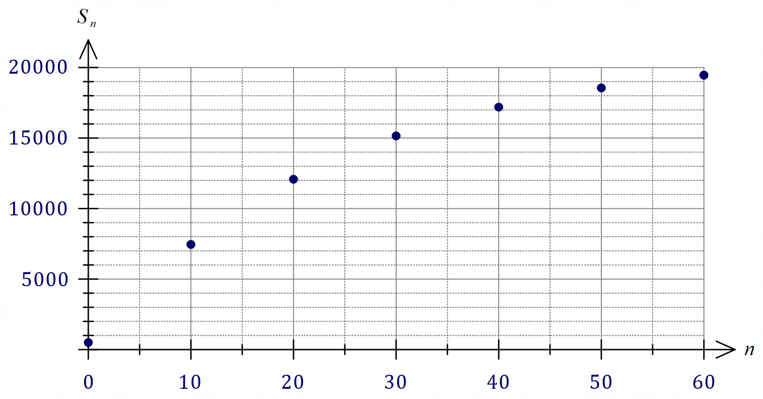
Solution
See graph
Specific behaviours
adds scale
ü at least 4 points
ü all points

(d) Describe the feature of the plotted points that indicates the salt concentration will eventually reach a steady-state. (1 mark)
Solution
Describes 'levelling off' or 'increasing at a decreasing rate', etc.

Specific behaviours
reasonable description

(e) Determine, with justification, the steady-state salt concentration. (2 marks)
Solution
$$S=0.96S+850⇒S=21 250 \text{ppm}$$

Specific behaviours
equation, or explanation using term(s) with large $n$
ü correct concentration

Question 17 (7 marks)
Loans are offered by lender $A$ at a rate of $10.32\%$ per annum compounded quarterly and from lender $B$ at a rate of $10.22\%$ per annum compounded daily.

(a) Calculate the total amount that must be repaid if $\$1500$ is borrowed from lender $A$ for
nine months. (2 marks)
Solution
$$A=1500{\left(1+\frac{0.1032}{4}\right)}^{4*\frac{9}{12}} \\ A=1619.12$$  Hence $\$1619.12$ must be repaid. | Financial calculator  $$N=3, I\%=10.32,PV=-1500 \\ PMT=0, P/Y=4, C/Y=4$$  Solve for $FV=1619.12$  Hence $\$1619.12$ must be repaid.
Specific behaviours
shows compound interest formula or values used in financial calculator
ü correct amount

(b) Calculate the total interest that will be charged on a loan of $\$90 000$ from lender $B$ for
$30$ days. (2 marks)
Solution
$$A=90 000{\left(1+\frac{0.1022}{365}\right)}^{365*\frac{30}{365}} \\ A=90 759.08$$  Hence $\$759.08$ interest charged. | Financial calculator  $$N=30, I\%=10.22,PV=-90000 \\ PMT=0, P/Y=365, C/Y=365$$  Solve for $FV=90 759.08$  Hence $\$759.08$ interest charged.
Specific behaviours
shows compound interest formula or values used in financial calculator
ü correct amount of interest

(c) Minimising loan interest is the primary goal for a borrower. Calculate the effective interest rate for each lender and hence recommend which should be chosen. (3 marks)
Solution
Lender $A:N=4, APR=10.32\%, EFF=10.7263\%$.

Lender $B:N=365, APR=10.22\%, EFF=10.7589\%$.

Hence interest will be minimised by choosing lender $A$
(as their effective interest rate is less than that of lender $B$).

Specific behaviours
effective interest rate for $A$
ü effective interest rate for $B$
ü uses effective rates to choose lender

Question 18 (7 marks)
When a city bypass is closed, traffic that would normally use it is forced to flow through main roads in the city. The edge weights on the directed graph below show the maximum number of vehicles per minute that can travel between junctions (represented by vertices) without causing congestion in the city.
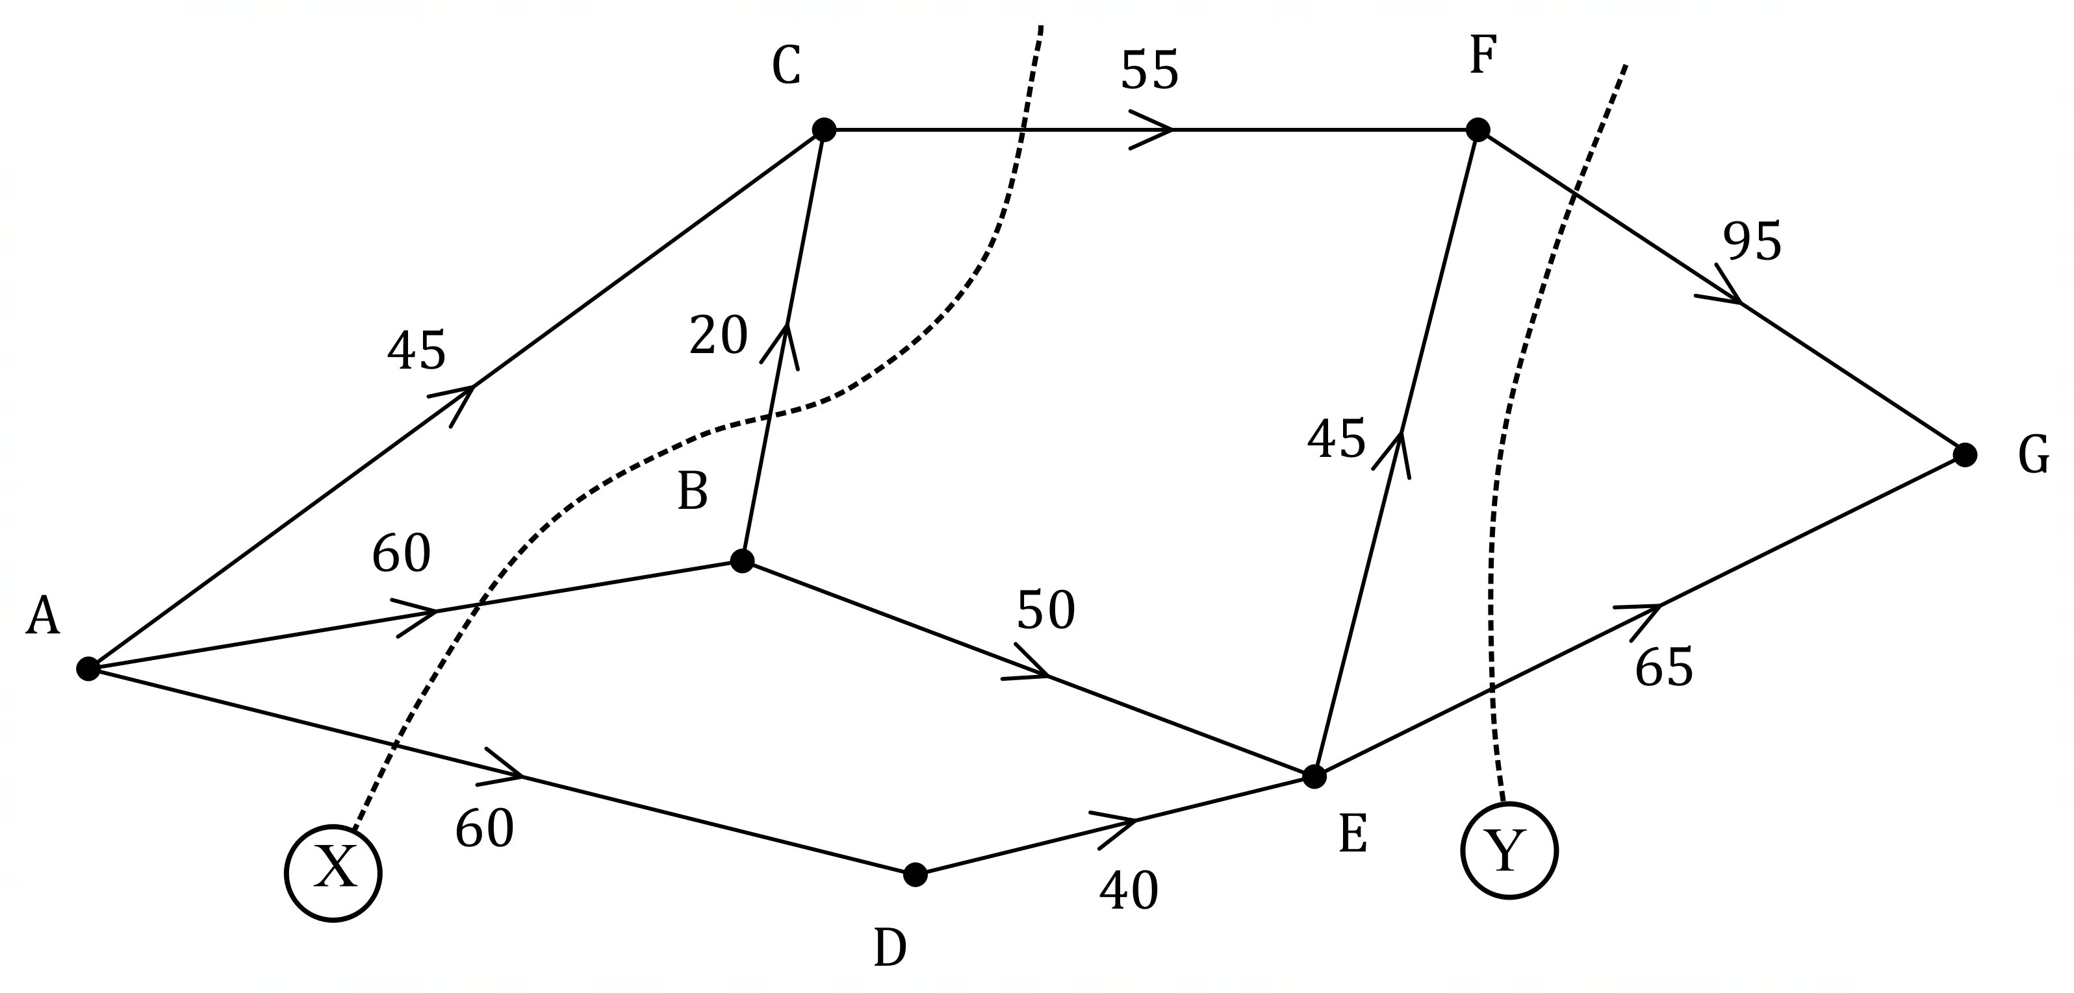

(a) Determine the value of cut $X$ and the value of cut $Y$. (2 marks)
Solution
Cut $X=60+60+0+55=175$ vpm. Cut $Y=65+95=160$ vpm.

Specific behaviours
value of cut $X$
ü value of cut $Y$

(b) Determine the maximum flow of vehicles per hour from $A$ to $G$. (3 marks)
Solution
$ACFG=45; ABCFG=10; ABEFG=40; ABEG=10; ADFG=40;\text{Total}=145$.
OR
Minimum cut is $55+50+40=145$.

Maximum hourly flow is $145×60=8700$ vehicles per hour.

Specific behaviours
indicates systematic listing or several cuts
ü correct maximum flow per minute
ü correct maximum flow per hour

(c) City engineers recommend taking steps to improve traffic flow between junctions $D$ and $E$. Determine, with reasoning, the maximum increase in the hourly flow of vehicles from $A$ to $G$ that their plan could achieve. (2 marks)
Solution
Spare capacity along $ADEG$ is $20∙0∙15$, so increase by $15$.
OR
Minimum cut not using $DE$ is $160$, so $160-145=15$.

Maximum possible increase is $15×60=900$ vehicles/hour.
Specific behaviours
reasoning
ü correct increase

Question 19 (8 marks)
A fund with a balance of $\$425 000$ is used to create an annuity, from which regular withdrawals of $\$9500$ are to be made at the end of each quarter. Interest at a rate of $6.8\%$ per annum is added to the fund quarterly, just before each withdrawal.

(a) Use one or more calculations to show that the balance of the fund after one withdrawal
is $\$422 725$. (2 marks)
Solution
$$425 000×0.068÷4=7225$$  $$425 000+7225-9500=422 725$$ | $$6.8÷4=1.7$$  $$425 000×1.017-9500=422 725$$
Specific behaviours
indicates adjustment for interest for one quarter
ü calculation: interest less withdrawal or recursive type

(b) Write a recurrence relation to calculate the balance $T_{n}$ after the $n^{th}$ withdrawal. (2 marks)
Solution
$$T_{n+1}=1.017×T_{n}-9500, T_{0}=425000.$$

Specific behaviours
correct recursive part
ü correct statement for $T_{0}$

(c) Determine the total interest earned by the fund during its first year of operation. (2 marks)
Solution
$$T_{4}=415 665.31$$

$$415 665.31+4×9500-425 000=\$28 665.31$$

Total interest is $\$28 665.31$.

Specific behaviours
indicates closing balance
ü correct total interest

(d) The amount of the regular withdrawal from the fund can be modified so that from the outset, the fund is a perpetuity rather than an annuity. Determine the withdrawal required for this to occur. (2 marks)
Solution
Withdrawal is interest for one quarter: $425 000×0.068÷4=\$7225$

Amount of withdrawal is $\$7225$.

Specific behaviours
indicates withdrawal must be interest for one quarter
ü correct amount

Question 20 (8 marks)
For each quarter in the $12$ years from $2006$ to $2017$, a city library calculated its mean number of users per day and used seasonal indices to deseasonalise the data. A snapshot of the data for the year $2015$ is shown in the table below.

Quarter | $$1$$ | $$2$$ | $$3$$ | $$4$$
Mean daily users | $$415.4$$ | $$465.4$$ | $$462.6$$ | $$407.0$$
Deseasonalised mean daily users | $$436.5$$ | $$442.7$$ | $$431.7$$ | $$439.8$$

The trend line for the deseasonalised mean daily users is $\hat{n}=722-8.1t$ where $t$ is the quarter and $t=1$ corresponds to the first quarter of $2006$.

(a) State, with justification, whether the mean number of users per day was increasing or decreasing over the $12$ years. (1 mark)
Solution
Decreasing - slope of trend line is negative

Specific behaviours
states decreasing, justifies with slope

(b) Calculate the seasonal indices and enter them in the following table. (2 marks)

Quarter | $$1$$ | $$2$$ | $$3$$ | $$4$$
Seasonal Index | $$0.952$$ | $$1.051$$ | $$1.072$$ | $$0.925$$
Solution
See table: Decimals to at least $2$ dp (or equivalent as percentage).
$$415.4÷436.5=0.952, 1.051, 1.072, 0.925$$
Specific behaviours
at least two correct and indices sum to $4$
ü all correct

(c) State, with justification, in which quarter the library was usually busiest during the period that data was collected. (2 marks)
Solution
Third quarter - the seasonal index is highest for this quarter.

Specific behaviours
correct quarter
ü justifies using indices

(d) Determine an estimate, to the nearest whole number, for the mean daily users the library experienced in the first quarter of $2017$. (3 marks)
Solution
$$t=45 \\ \hat{n}=722-8.1\left(45\right)=357.5 \\ 357.5×0.952≈340$$
Estimate there were $340$ users.

Specific behaviours
correct value of $t$
ü calculates $\hat{n}$
ü seasonalises to obtain correct estimate

Question 21 (7 marks)
An electronics store advertises a TV for sale at a price of $\$5950$. Rather than pay this amount in full, the store offers customers a no deposit reducible balance loan with $24$ monthly payments of $\$281.20$. The first repayment is due one month after the customer makes the purchase, just after interest for the month is added to the loan balance.

(a) Determine the total interest paid by customers who buy the TV using the loan. (2 marks)
Solution
Repay: $24×281.20=\$6748.80$

Interest: $6748.80-5950=\$798.80$

Specific behaviours
calculates total repaid
ü calculates interest

(b) Determine the annual percentage interest rate that applies to the loan. (2 marks)
Solution
Using Financial app:
$$N=24, PV=5950, PMT=-281.20, \\ FV=0, P/Y=12, C/Y=12$$

Solve for $I\%=12.4$, so rate is $12.4\%$ per annum.

Specific behaviours
shows correct values for financial calculator
ü correct annual rate

A customer decides to buy the TV using a similar reducible balance loan to that offered by the store but financed by their bank at an annual interest rate of $13.98\%$ and over $36$ months.

(c) Determine their monthly repayment. (2 marks)
Solution
Using Financial app with:
$$N=36, PV=5950, I\%=13.98, \\ FV=0, P/Y=12, C/Y=12$$

Solve for $PMT=-203.30$, so their repayment is $\$203.30$ per month.

Specific behaviours
shows correct values for financial calculator
ü correct repayment

(d) Determine the total interest that the bank will charge on the loan over the $36$ months.
(1 mark)
Solution
Using Financial app: $∑INT=-1368.77$.
Using $36×203.30-5950=1368.80$.
Total of $\$1368.77$ or $\$1368.80$ in interest.

Specific behaviours
correct amount

Supplementary page

Question number: _________

Supplementary page

Question number: _________

© 2021 WA Exam Papers. Kennedy Baptist College has a non-exclusive licence to copy and communicate this document for non-commercial, educational use within the school. No other copying, communication or use is permitted without the express written permission of WA Exam Papers. SN245-186-4.

